Electronics Recycling Day
at
St. John the Evangelist
(752 Big Oak Road, Morrisville, PA 19067)
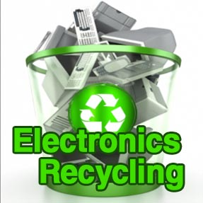
When: Saturday, September 17, 2022
Time: 9:00 AM to 1:00 PM
Where: St. John the Evangelist (SJE) Parking Lot
Who: People Advancing Reintegration (PAR)
Why: Protect the Environment

“PAR-Recycle Works is a nonprofit electronics recycler that provides transitional employment to people returning from prison. We deconstruct electronics and destroy data to generate revenue and pay our employees. By providing our employees with skills and opportunities, PAR-Recycle Works helps to build safer communities and contribute to stronger families while saving taxpayer money.”

(To learn more about this wonderful ministry, please visit home.par-recycleworks.org.)

- All are welcome to drop off electronic waste between 9:00 AM and 1:00 PM.
Follow the signs at any entrance.

- Items accepted with no charge: small appliances, computers, printers, small office electronics,
cellular phones, cable & wiring, copiers, scanners, projectors, speakers, cameras, keyboards, modems, routers, laptops, radios, electronic toys, gaming devices, stereos, tablets, CD players, VCR’s, computer equipment. (Note: All data on hard drives will be destroyed.)
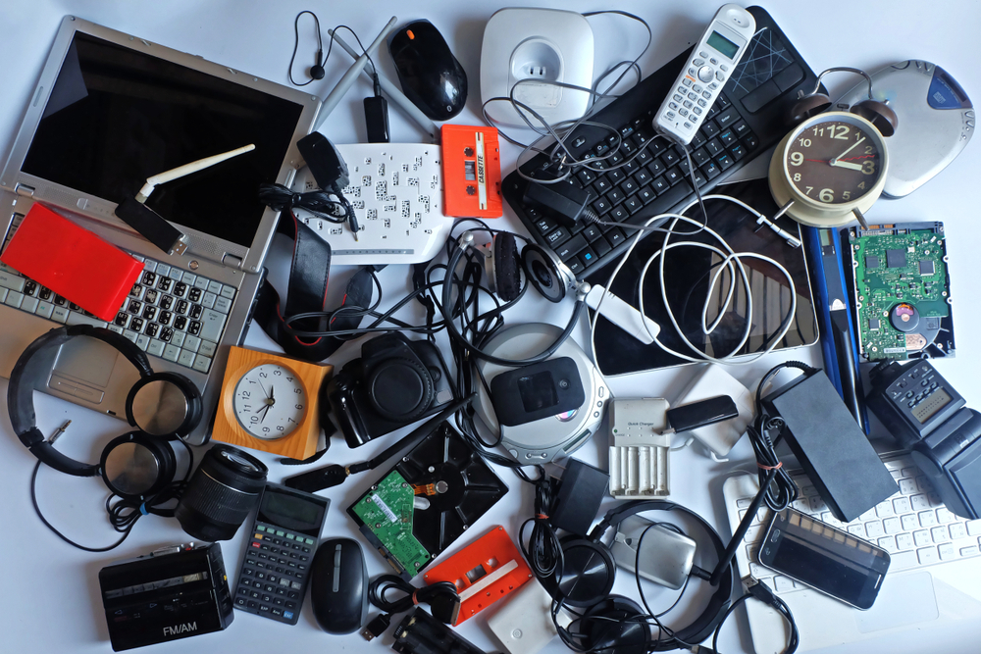
- The following items include a cost to ensure they are properly recycled:

Microwave ($10), Flat-screen Television ($20), Air-conditioner ($20), Dehumidifier ($20), Air purifier ($20), Computer monitor ($5),
Older CRT monitors and TVs: $35-$75 each (size varies).

Cash or personal check written out to “PAR-Recycle Works” is accepted.

- Please place donated items in the trunk or back seat of your vehicle before arriving at the SJE drop-off location. Pull up to one of the next volunteers who can assist you. STAY IN YOUR VEHICLE. Pop your trunk and/or unlock your back door. Please let the volunteer remove the donated item(s) from your back seat and/or trunk.

If you do not see an electronics item that is listed, please send an e-mail message to
Maurice at info@par-recycleworks.org or call #267-335-5455 to determine if
any of your electronics items can be accepted for recycling.

(Please recycle this piece of paper. Thank you!)

