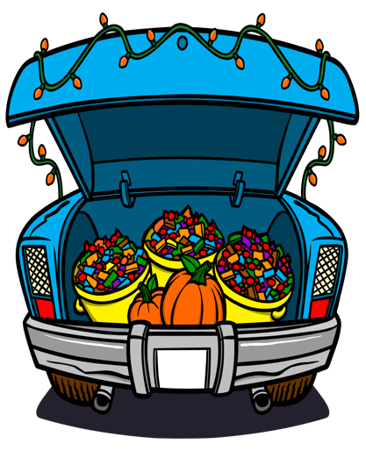

Youth Ministry is hosting an

All Saint’s Day Trunk-or-Treat

on Saturday, October 28, 2023

from 5:30-7:30 p.m.

in St. John’s Parking Lot

**KIDS–**

Join us in full costume for fun activities, and prizes to follow trunk or treating!

We encourage Saint-themed costumes and trunks, but normal Halloween costumes and decorations (kid friendly, of course) are welcome!

Every child dressed as a Saint will receive a special treat!

**WHAT IS A TRUNK-OR-TREAT?**

Trunk-or-Treating is a fun, safe alternative to trick-or-treating. People decorate open car trunks and give out candy or treats to children, who walk from one parked car to another with their families. Trunk or Treat is an option for children to enjoy a safe, fun activity with their families.

**GROWN-UPS–**

Join us in teaching our children about All Saints Day by decorating your trunk with creative Catholic/Saints approach. Spooky (please not gory) trunks are welcome, but we encourage a catholic approach. We need lots of vehicles to fill our parking lot.

If you would like to setup as a trunk host to hand out candy please email: [youthministries@stjohnpa.org](mailto:youthministries@stjohnpa.org) and or click here:

<https://www.signupgenius.com/go/10C084AAAA829A4FEC34-45472499-trunkortreat>

Please arrive and set up between **4:45 p.m. -5:15 p.m.**

We ask you to please bring with you enough candy for about 50 children. (two bags of candy). We are also taking up a collection for additional candy to be shared among the host trunks.

Decorating your trunk is appreciated but not required to participate.

All trunk participants will be entered into a raffle to win an italian themed gift basket that includes a $50 Gift Certificate to Michael’s Restaurant!

We will offer a prize for the best religious themed truck.

Need Trunk Saintly or Non-Gory Decorating Ideas?

<https://www.catholicicing.com/all-saints-day-trunk-or-treating-ideas/>

<https://www.pinterest.com/maryjanelau/trunk-or-treat/>

**Please consider being a trunk host – We need YOU for this event to be a success!! Thank you!**